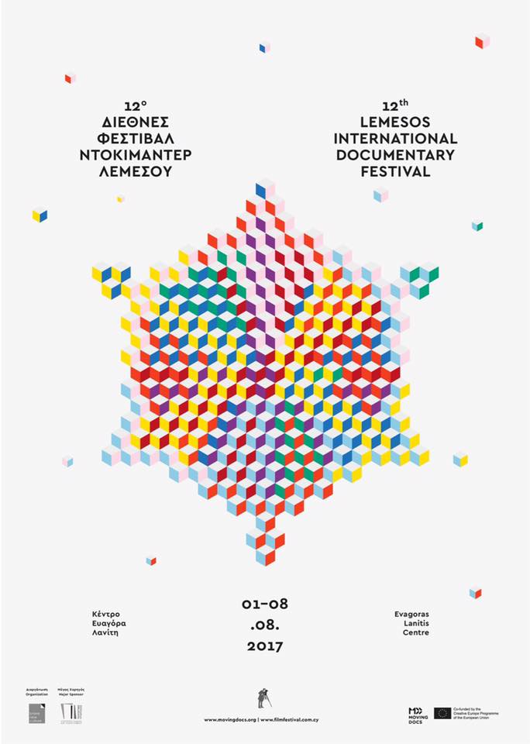

'Lemesos International Documentary Festival'
Welcome to the ''Lemesos International Documentary Festival'', organized by Brave New Culture.
Major Sponsor of the Festival is the Cultural Services of the Ministry of Education and Culture of Cyprus and is organized in collaboration with CyBC (Cyprus Broadcasting Corporation).
The 'Lemesos International Documentary Festival' is part of Moving Docs, a new EDN initiative supported by Creative Europe, founded for the joint distribution of documentaries across Europe.
The 2017 edition of the Festival will take place between the 1st and 8th of August 2017.
More info on http://filmfestival.com.cy/

